Time Management

How much time does activism take? How can I have time for activism?

At times you may be asking yourself some or all of the questions above—as many have. Not having enough time to accomplish all that you want to do is a problem that is widespread in the modern world. As a student—and especially if you are a freshman—college can seem overwhelming. The constraints that classes, assignments, school clubs and organizations, jobs and internships, and having a social life place on you can be immense at times. Moreover, activism more often than not takes a considerable amount of time, and more than one might think. So how much time does participating in some form of activism take?

Activism Takes Time

When most people think of activism, they may think of a large protest event such as the one in the image above, which can last anywhere from a few hours to several days. They figure that in order to take part they only need to allocate time for the main event of the whirlwind moments, the perfect photo-op with the colorful signs and chanting voices, and that it’s mostly going from one whirlwind to another. But in reality, there is so much more that goes into events such as a protest or other display of activism. Even in terms of basic logistics, there are countless hours that go into the set up and takedown of events like these, which is easy to overlook.

Furthermore, in order to have a movement, there needs to be organization, collective action, and hard work—these whirlwind moments almost never come up accidentally, and are often the result of years of hard work and dedication by many people. The extent of this organization varies widely, but very often there are people working on recruitment, fundraising, and organizing to make the big whirlwind moments possible. Think of how activism is a collective action problem—there are even degrees of this among activists themselves, because some are in it for the long haul, while others are only looking for the low hanging fruit. This doesn’t mean that you need to take an all-or-nothing approach to activism, but be aware that effective activism takes time, and more than most initially realize.

So how do I make time for activism?

The most important thing when it comes to allocating time for activism is prioritizing your time, your values, and your actions. Try to be clear with yourself about what you care about, what you want to change, and how much you care about achieving this change. It can feel like there’s no way you could possibly have enough time to do everything in your life and create change in the world around you, but understanding your level of involvement is as simple as answering this question: What are you willing to do to make it happen?

It is important to note that there are a lot of easy ways to get involved in activism, and many have a low barrier to entry. We want to give you the tools and ideas to (at the very least) just get started; and if you find the right combination of time, passion, and priority to want to do more, there are always ways to dig deeper. So whether you’re looking to start a worldwide movement to fundamentally change society or just want to help out on an issue that is important to you, there are plenty of ways to get involved, live your values, and start working for a better world.

When you are first getting started, you can find smaller ways to get involved or help other activists that are less time consuming. As you become more involved and figure out what is important to you, you can always re-assess your values and how they relate to your time allocation. There is room between being a full-time activist and doing nothing, so find your balance, and consistently reassess how you spend your time. Do what you can with the time you have.

Why Students?

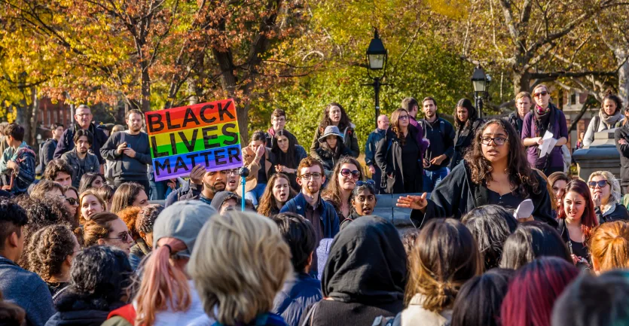

College is a time for learning, growing, and having fun. Activism is an opportunity for you to experience some (or all!) of these three things as well. Trying to have some impact on the world is arguably part of the college experience—otherwise what is the point (besides to become a cog in the capitalist machine)? Participatory experience is the best teacher, and taking things you learn and putting them to work in the real world is one of the best things you can do to learn and grow as a person—see our section on activism for students by year for more.

There is a long history of impactful student activism, so don’t doubt your potential, even with all the time constraints you have. Don’t feel like you can’t participate if you’re not a full time activist—this is one of the great illusions that prevents a lot of positive change in the world. Your goal as an activist should be to become aware of important issues in society, prioritize those you care most about and can positively affect the most, and work to create as much change as you can with the resources—including time—that you have.

