THEORY TO STRATEGY: DIAGNOSIS, PROGNOSIS, MEANS
QUICK LINKS
- Pillars of Support
  - Figure A. Pillars of Support
- Root of Inequalities
  - Figure B. Root of Inequalities
- Next Steps
  - If you want mass public support (strategic nonviolence)
  - If mass public support is not your goal (diversity of tactics)
    - Figure C. Intersecting Spheres of Influence
    - Figure D. Disruption versus Concession Costs

To engage in efficacious activism, we must consider how to narrow the gap between the world in which we live and the world in which we wish to live. We can accomplish this by answering a series of three questions. First, what is our diagnosis of the problem we wish to solve? In answering this question, you may consider from where in society you believe these problems stem. Second, what is our prognosis of what the world should be? Third, which means will best push us from our diagnosis to our prognosis? This section details two theoretical orientations with contrasting answers to these questions and provides additional research on how to conceptualize the transition between theory and strategy. These overarching theories and data intend to promote your reflections, discussions, and answers to the three questions of what you and your movement find to be the (1) diagnosis, (2) prognosis, and (3) means.

PILLARS OF SUPPORT
The first theoretical orientation is referred to as the PILLARS OF SUPPORT MODEL (Figure A). This model diagnoses problem(s) that arise from unequal treatment of the public by the law and political elite. Political scientist Gene Sharp, the accredited founder of this model, argues the consensual domination of social institutions such as the military, universities, mass media, and businesses “lend[s] structural stability to a political system” that promotes injustice (Engler & Engler 2016, p. 92). Proponents of this model contend that shaking these “pillars” by garnering public support will topple the political system from which inequalities stem (Engler & Engler 2016, pp. 92-96). Put differently, involving larger swaths of the population and swaying public opinion will encourage institutions that organize people to fall in support of the movement. After toppling the unjust political system, activists will help usher in greater rights for all with subjectively better political leaders and institutions.
The pillars of support model intends to achieve transformational—rather than transactional, electoral politics-based—social change by way of “mass public support and participation” (Engler & Engler 2016, p. 26 & pp. 96-97). According to this model, the most persuasive means by which activists can gain public support is through strategic nonviolence via Sharp’s idea of political jiu jitsu (Engler & Engler 2016, p. 6). This view posits that the State will almost always retaliate against movement activity—violent or nonviolent—with violence through the backing of the police and military. In other words, the State is an expert in violent methods. By reacting to this violence with strategic, unwavering nonviolence, movement activists can gain widespread public sympathy necessary to shaking the pillars of support (Engler & Engler 2016, p. 6). Advocates of this model argue that the State, through the consensual domination of its people, has greater legitimacy to use violence to quell violent protest activity. As follows, attempting to beat the State at its own violent game is a surefire way to lose public support and prospective gains for your movement (Engler & Engler 2016).
Figure A conceptually illustrates the pillars of support model. In sum, this model diagnoses problems as stemming from the political system, provides a just and fair political system as the prognosis, and argues strategic nonviolence is the best means to address injustice. The black bar in this figure represents the diagnosis (i.e., “Corrupt Political Institution, Individuals, Interactions”), and the red arrows point to where proponents believe activism should be directed (i.e., “the pillars”).

FIGURE A. PILLARS OF SUPPORT MODEL.
DIAGNOSIS: Political/Legal Inequalities || PROGNOSIS: Just and Fair Political System
MEANS: Strategic Nonviolence
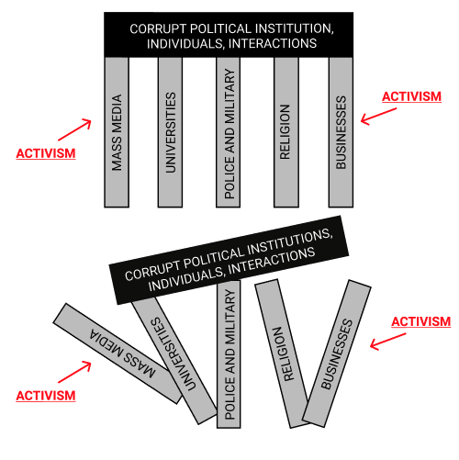

ROOT OF INEQUALITIES
The second theoretical orientation to diagnosis, prognosis, and means is referred to as the ROOT OF INEQUALITIES MODEL (Figure B). Proponents of this model diagnose power inequalities as arising from hierarchical systems of political and social organization. Put differently, the structural foundations upon which society is currently built give rise to injustice. This foundation, or “root of inequalities,” may take the form of Capitalism, the Patriarchy, or other overarching sources of structural inequalities. Directing activism toward social institutions (i.e., “the pillars”) is antithetical to liberation, as direct individual action against oppression—rather than swaying public opinion—is what leads to revolutionary success (Gelderloos 2013, p. 119, p. 304). The prognosis this model might seek if followed to anarchist ends is the complete reorganization of society into autonomous, decentralized communities (Gelderloos 2013, pp. 45-47, p. 261).
Proponents of this model support using a diversity of tactics as the means to close the gap between the current world and the envisioned future. In this framework, activists can coexist while engaging in a variety of actions they find natural, needed, and effective in addressing their struggles (Gelderloos 2013, p. 303). Employing a diversity of tactics is not meant to act as a “trojan horse for centralization and domination” but rather a strong embrace of multiple different methods of addressing inequalities (Gelderloos 2013, p. 303). This model rejects strategic nonviolence as the sole means of movement activity because of its authoritarian nature. Specifically, it calls attention to how ardent nonviolence activists advance their ideology at the expense, oppression, and eradication of all other means (Gelderloos 2013, p. 237). “Peace police,” or protesters who call the cops on other activists engaging in activities they deem “violent” such as property destruction, for example, breach a sacred bond of solidarity through a diversity of tactics lens.
Figure B conceptually illustrates the root of inequality model. This model diagnoses underlying structures as “the root” cause of struggles, identifies the collapse of the current social and political order as a prognosis, and advocates for a diversity of tactics to achieve these ends. Like Figure A, the black bar represents the diagnosis (i.e., “The State, Capitalism, Patriarchy”), and the red arrows point to where proponents believe activism should be directed.
FIGURE B. ROOT OF INEQUALITIES MODEL.
DIAGNOSIS: The State/Capitalism/Patriarchy || PROGNOSIS: Autonomous, Decentralized Communities
MEANS: Diversity of Tactics
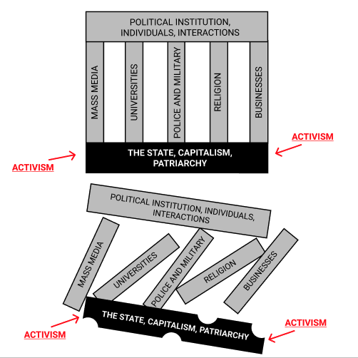

NEXT STEPS
You need not agree with each answer these models provide to the questions of (1) diagnosis, (2) prognosis, and (3) means. Instead, these models should encourage you to assess how you personally—and how others in your movement—approach and understand your struggles. You may consider (a) from where in society might power inequalities stem, (b) who in society has the greatest liberatory potential, and (c) how important garnering support from the public majority is to your cause. Your answers to these additional questions will assist in discovering what you agree and disagree with in both the pillars of support and root of inequalities models.
These models differ in their response to the questions posed. For the pillars of support model, (a) power inequalities stem from unjust political leaders and laws, (b) the public and its organizing institutions have the greatest liberatory potential, and thus, (c) garnering mass public support via strategic nonviolence is integral to success. For the root of inequalities model, (a) power inequalities stem from the structural foundations of society, (b) a diversity of actors coexisting in their actions have the greatest liberatory potential, and (c) garnering mass public support need not be a goal of activist movements. The pillars of support model views civil resistance as “inherently democratic” due to its reliance on “mass public support and participation if they are to succeed” (Engler & Engler 2016, p. 26). Differently, the root of inequalities model views resistance as inherently anti-democratic since since most movement activity is initially opposed by the public majority (Gelderloos 2013, p. 118). Since public support distinguishes the two models, it is helpful to decide whether mass participation and favorable public opinion are necessary for your movement.

STRATEGIES IF YOU WANT MASS PUBLIC SUPPORT…
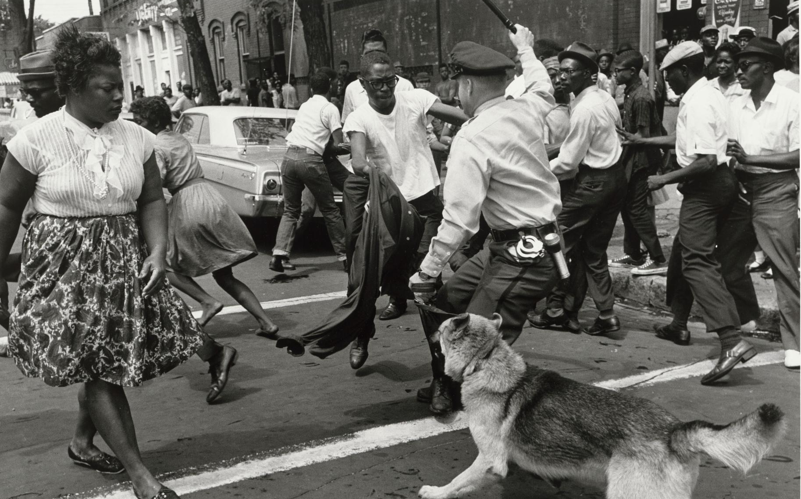
The Birmingham Children’s Crusade, 1963.
National Museum of African American History & Culture

You can concentrate energy on the mass media, elite/public support, and political leaders. Gene Sharp’s aforementioned concept of political jiu jitsu is important to keep in mind; exposing how your peaceful resistance is met with violent State suppression can help gain public sympathy. This public support will help topple the pillars of support for the unjust political institution, individuals, and/or interactions.
A pertinent example of this tactic is the 1963 Birmingham Children’s Crusade (pictured above). As part of the 1960s Civil Rights Movement, hundreds of students gathered in Alabama to peacefully protest. Police attacked these young activists with dogs, clubs, and high-pressure fire hoses. The mass media publicized images of the attacks, such as the one above, causing widespread public outrage. This social upheaval placed pressure on political leaders to intervene, prompting President Kennedy to publicly express his support for civil rights legislation. Civil rights leaders made the decision to allow students to protest despite being fairly certain that the police would violently retaliate against the young activists (Engler & Engler 2016). They made this explicit choice in consideration of how publicizing police brutality against peaceful children would elicit strong public emotion and expose violence faced by Black people in America (Engler & Engler 2016).
Political jiu jitsu is inherently oriented toward affecting elite institutions and individuals. This nonviolent tactic relies on engagement from the mass media in order to sway public opinion and impact elite political leaders’ decisions and legitimacy to rule (Engler & Engler 2016). If you adopt the pillars of support model, then, it is useful to examine past research about how movements can best shape elite opinions.
The numerical strength and unity of social movements engaging in protest exert the strongest influence on politicians’ perceived salience of the issue(s) at hand (Wouters & Walgrave 2017). In other words, the amount of protestors at a given protest and the agreement these protestors display are of the utmost importance in influencing elite understanding of your movement (Wouters & Walgrave 2017). Taking this finding into account, we suggest you focus on improving movement event turnout and establishing clear motivations and goals for your activism. You may take to social media to raise awareness about the event (re: Internet Activism), create a webpage or flyers listing your movement’s intentions, and/or rally around a specific phrase (re: Crafting Your Message). But these are merely suggestions; we encourage you to have further conversations with you fellow activists to increase the numerical strength and unity of your movement.
Furthermore, elite support and favorable public opinion can shape the impact your movement has on the legislative process. Despite directing activism toward social institutions instead of toward ruling political bodies, de jure change remains the ultimate goal for advocates of the pillars of support model (Engler & Engler 2016, p. 26 & pp. 96-97). As such, legislative and/or litigative change is an important objective for movement organizations following an ideology of strategic nonviolence. Soule & Olzak (2004) argue that elite support strengthens the impact of movements on legislative action, and that public opinion matters most for legislation ratification when electoral competition is low. These nuanced findings suggest that elite allies are important (though not necessary) in furthering your movement’s legislative goals, and that high public support is especially impactful in moments of low electoral competition (Soule & Ozak 2004). With this research in mind, you may want to allocate greater energy to gaining elite and public support during non-election years or within non-competitive electoral districts/states. This suggestion may seem counterintuitive, as activism is commonly associated with times and spaces of contentious electoral politics. But this literature urges you to specifically concentrate your “shaking” of the pillars when the political environment—a component of the political opportunity structure—appears to be non-threatening and calm.

STRATEGIES IF MASS PUBLIC SUPPORT IS NOT YOUR GOAL...
You can consider which tactics are most effective given the context in which your movement is situated. The process of choosing which tactics to use is necessarily tied to how you evaluate success (re: Evaluating Success, Tactics). It is useful to consider three intersecting spheres of influence when strategizing: (1) movement claims (e.g., issue-focus, demands), (2) effects of movement actions, and (3) effects outside of events and actions (Tilly 1998 via Giugni 1998; Figure C). The only sphere your movement can (partly) control is movement claims; strategizing and framing can help you influence the effects of your actions (Soule & Olzak 2004), but effects outside of your actions are out of your control. Recognizing how these spheres intersect can broaden your considerations and conversations about choosing tactics from the diversity of tactics available.

FIGURE C. INTERSECTING SPHERES OF INFLUENCE
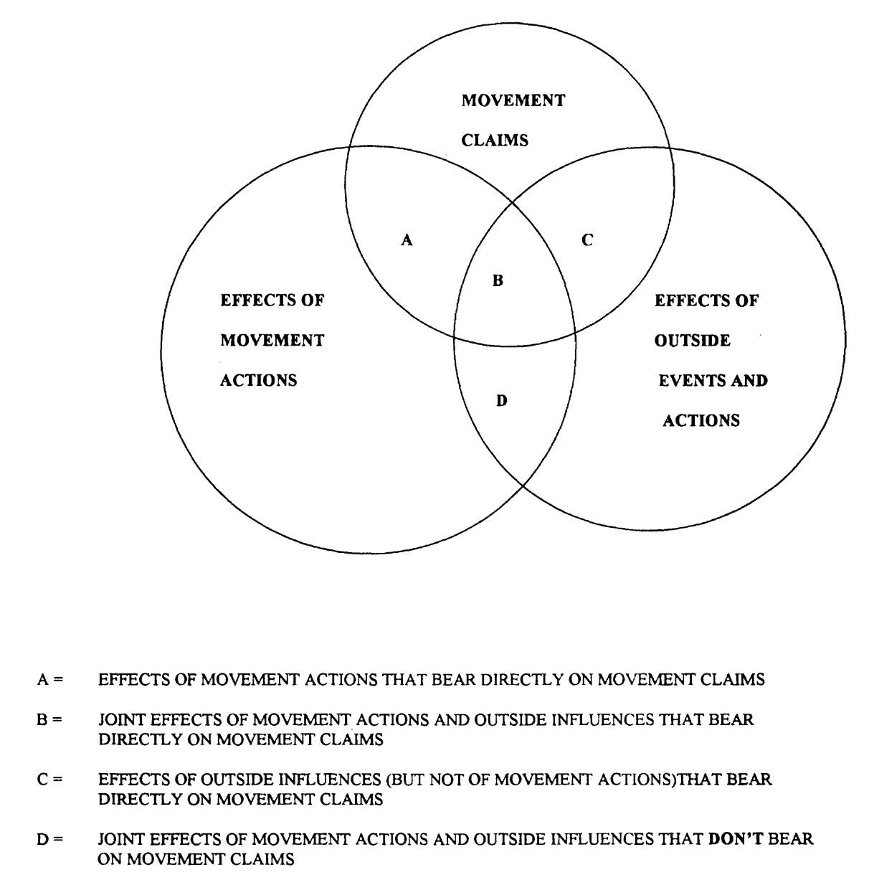
Once you acknowledge that various spheres of influence affect your movement, you may turn your attention to what mechanisms bridge (a) the actions you take and (b) the effects of these actions. Strong strategy involves a cost-benefit analysis of possible tactics that considers how (a) gets to (b). Put simply, you can strategize by considering how your movement actions will be received by the opposition (e.g., who/what you are confronting). The disruption-concession framework used by Luders (2006) is a useful example of using this mentality (Figure D).

FIGURE D. DISRUPTION VERSUS CONCESSION COSTS
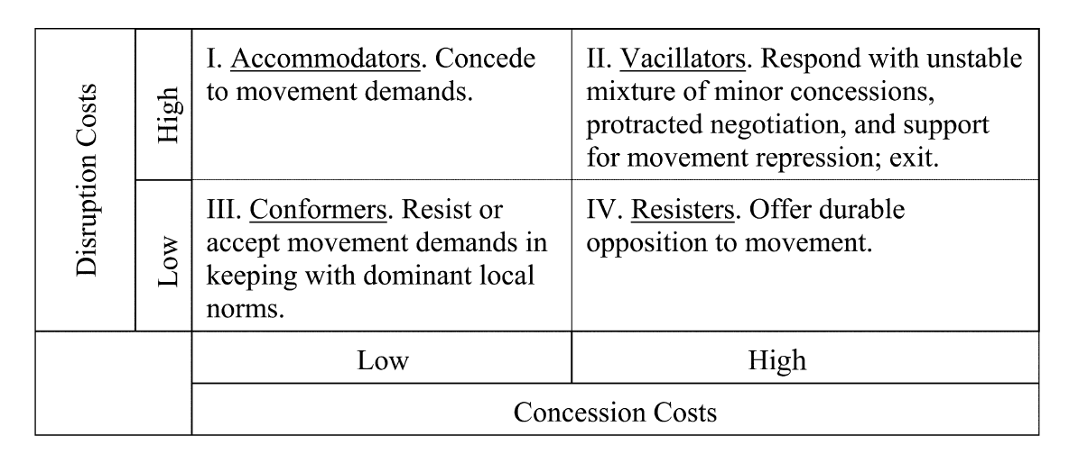
“The Economics of Movement Success: Business Responses to Civil Rights Mobilization”
Joseph Luders (2006)

In this model, the target of your movement assesses the cost of disruption (e.g., movement activity) versus the cost of concession (e.g., conceding to movement demands). Ideally, the costs of disruption will outweigh the costs of concession, prompting your opponent to give into your demands (i.e., turning the opposition into “accommodators”). In the worst case scenarios, disruption costs remain low and your opponent never concedes to your movement demands (i.e., “conformers” or “resisters”). You also do not want high disruption costs and concession costs, as your opponent will only partly concede while working to undermine your future efforts.
When choosing from your arsenal of tactics, then, you should consider how your oppressor(s) function. You can use multiple tactics, seeking to bolster disruption costs and minimize concession costs for your opponent—if you wish to have all your demands met. This does not mean you must concede to your opponent; you may certainly ask for costly changes, though you should keep in mind the opposition’s tendency to vacillate in response. This consideration may temper how disruptive you intend your tactics to be, as to not prompt complete repression of your movement.
Consider a hypothetical example to illustrate this strategy. “Student Group” is advocating for higher minimum wage for student workers. Their target (i.e., the opposition) is the University, and so “Student Group” strategizes by considering how possible actions will affect concession and disruption costs for the University. They decide to stage sit-ins at all cafeterias on campus, where many students are employed. These sit-ins are highly disruptive to the University because they halt normal dining hall operations, which is a service the University provides to paying students. The concession costs—that is, raising student minimum wage—is also high, so the University vacillates between different ideas for concessions. Since the disruption costs are not “excessively” high, the University does not immediately shut down the student protestors with force (e.g., the city or campus police). Eventually, the University agrees to provide smaller benefits (e.g., meal vouchers) to student employees. While the University did not fully meet the demands of “Student Group,” they did minimally improve the conditions for student employees.
This example highlights the context-dependent and evolving nature of disruption-concession analysis. For instance, the University could have viewed the cafeteria sit-ins as “excessively” disruptive and shut them down with force. It was up to the “Student Group” to strategically assess how the University would perceive the disruption and concession costs of their movement activity. Similarly, you must examine—and re-examine—how your opposition will counter your movement activity.

