Nicholas Guy
Professor Davenport
Polsci 489, Sect. 004
23 April 2021
Student-Athlete Activism: Operating within the Existing Infrastructure

“Sport has the power to change the world. It has the power to inspire. It has the power to unite people in a way that little else does. Sport can awaken hope where there was previously only despair. It laughs in the face of all types of discrimination.”
Nelson Mandela, activist, revolutionary and political leader

Student-Athletes are a powerful coalition group on college campuses across the United States that have a tenured history of being advocates for activist causes. In many ways, student-athletes are uniquely positioned as campus and community leaders, and actual representatives from colleges and universities, to use their voice and platform to drive social change on a number of topics such as racial justice, gender equity, LGBTQ+ inclusion, environmental activism, sexual violence prevention, immigration, and mental health issues. In many ways, sport is a powerful tool for social change. Research shows that there are commonalities between being an athlete and being an activist. Sport develops social consciousness, meritocratic ideals responsible citizenship and interdependence (Kaufman and Wolff, 2010). Throughout their time in college, student-athletes develop confidence, communication skills, teamwork and other qualities through playing their sport that supports their activist efforts.
This section of the handbook is tailored towards student-athletes on college and university campuses. In this section, student-athletes can gain information as to how they can operate within the existing infrastructure of their own athletic departments and within the NCAA. With these outlined resources, student-athletes can learn how they can affect change within their own team and communities.
Student-Athlete Resources and Existing Infrastructure
If you are a student-athlete and are reading this handbook, there are several ways in which you can become involved within your team and within your own athletic department.
- Contact, communicate, or become your team’s SAAC Representative
SAAC stands for “Student-Athlete Advisory Committee”. Student-athletes have a voice in the NCAA through advisory committees at the campus, conference, and national level. Each committee is made up of student-athletes assembled to provide insight on the student-athlete experience and offer input on the rules, regulations and policies that affect student-athletes’ lives on campus. Each team on campus has the opportunity to have at least one representative on the SAAC committee so each team is represented and voices are heard.
The mission of SAAC is to enhance the total student-athlete experience by promoting opportunity, protecting student-athlete welfare and fostering a positive student-athlete image. The function of the national SAAC’s: generate a student-athlete voice within the NCAA structure, solicit student-athlete response to proposed NCAA legislation, recommend potential NCAA legislation, review, react and comment to the governance structure on legislation, activities and subjects of interests, actively participate in the administrative process of athletics programs and the NCAA, promote a positive student-athlete image
Members of a campus SAAC have the opportunity to address issues affecting student-athletes at their institution; additionally, members have the opportunity to offer input on issues which may be national in scope, including controversial political and social movements. The campus SAAC may also serve as a conduit of communication among student-athletes, coaches and athletics administrators on issues to improve the student-athlete experience and promote growth and education through sports participation. Concerns can be voiced and solutions offered regarding any issue that may be relevant to NCAA student-athletes.
There are also relevant SAAC (E-Board) positions you should contact as well. One of these is the Chairman for Community Engagement. This member is largely responsible for contacting outreach programs within the local community so student-athletes can interact with causes which affect people around them. Another important position is the Officer for Diversity, Equity and Inclusion (DEI). This position is highly linked to the university’s DEI office, so there is collaboration between the student-athlete infrastructure and the offices within the governing bodies of colleges and universities.
SAAC one of the primary resources that is governed by student-athletes which can promote and affect change for this coalition group on college campuses as they allow student-athletes to voice their concerns on issues which affect their communities.
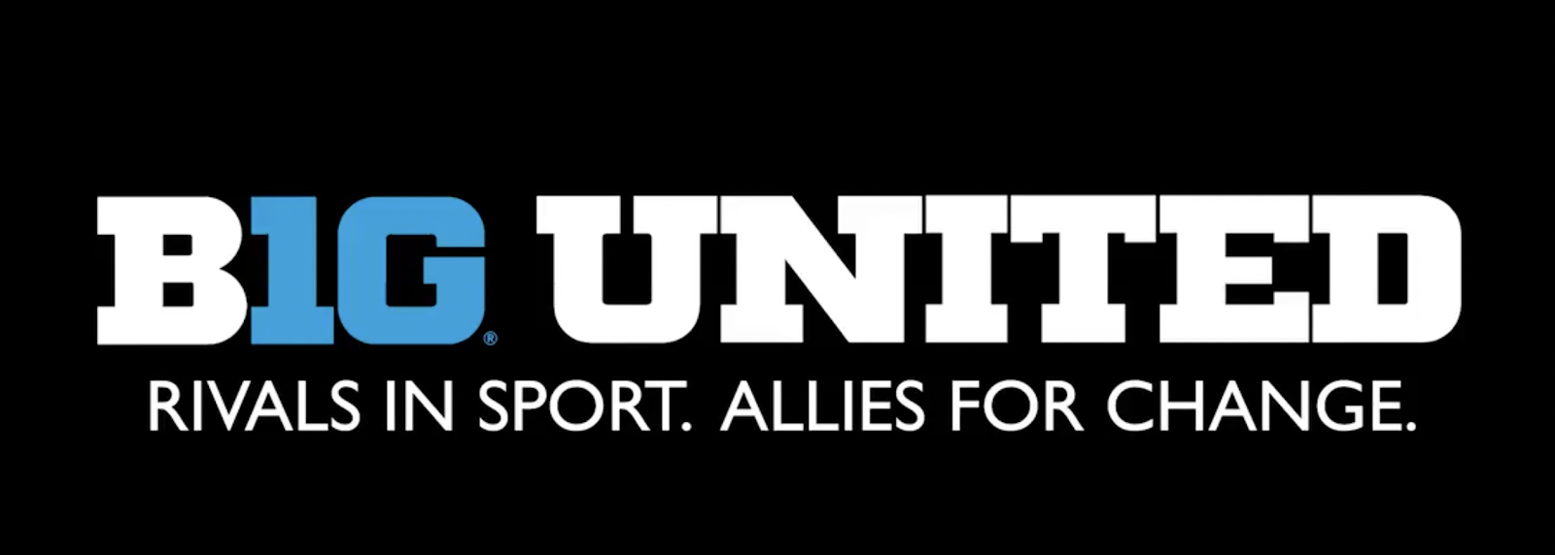
Slogan was created by SAAC members across universities in the Big Ten in Women’s Gymnastics. This message was printed out and worn by all competitors in their Big Ten Championships in response to the racial injustices experienced by African Americans in their sport and in their communities.

- Educating their team and fellow athletes on campus through “Athletes Using Their Power” (A4)
A4 is a great resource that is offered through the NCAA for all student-athletes and athletic departments. It is an NCAA leadership series that gives student-athletes a better understanding of how to use their voice and presence when addressing social injustices and other important topics in intercollegiate athletics. As athletes and sport administrators continue to seek best practices for implementing programs and opening conversations on campus, A4 has emerged as a top educational program allows student-athletes to learn different perspectives on how to be more impactful and enact meaningful change, while also allowing them to ask questions about experiences they’ve had. A4 is a four-part series that is split into different seminars:
Address Difficult Conversations: Participants will gain a skillset to effectively address issues of injustice and inequality that they observe or face within their daily lives. Registered attendees will explore how they can start the conversation on these topics, different approaches to discussing difficult subjects and the role of identity in addressing these issues. Facilitators will create a brave space for participants to engage with peers around their experiences, emphasizing listening and learning from one another.
Activism for the Student-Athlete: Athletes have stood on the frontlines of protests surrounding racial inequality, with examples in college sports including kneeling for the National Anthem and refusing to partake in donor events and workouts. It is evident that activism takes various forms. During this session, participants will learn what is activism, how it plays a role in sports and how they can use their voice to create change within their teams, campuses and communities. Participants will hear from a panel of student-athlete activists about their experiences, triumphs and challenges.
Allyship Best Practices: Allyship is critical to support many different groups and individuals, but the term is often misused and misunderstood. During this session, participants will learn what allyship looks like and how they can show up as an ally. The participants will gain an understanding of the importance of self-awareness, education and empathy as it relates to allyship.
Action Sustainability: Participants will engage in conversation on how they can best make this a movement and not a moment in history. This session will talk about the importance and power of voting, continuous education and changing culture so that diversity, inclusion, equity, and justice are embedded into the institution and community’s structure.
The A4 seminars are also a great resource for athletic administrators that allowed them the opportunity to better understand their athletes’ needs and to support them, listen to concerns they may have and help them act when change is necessary. Panelists were NCAA staff, college and university officials and subject matter experts on inclusivity and activism.
As described A4 is a great educational tool, but is also a guidebook for how student-athletes can become activists in their own communities while simultaneously working within their own existing athletic department, team, and infrastructure. By providing educational seminars for how student-athletes can best use their platform and implement activism strategies, A4 is a great resource that all student-athletes can utilize.
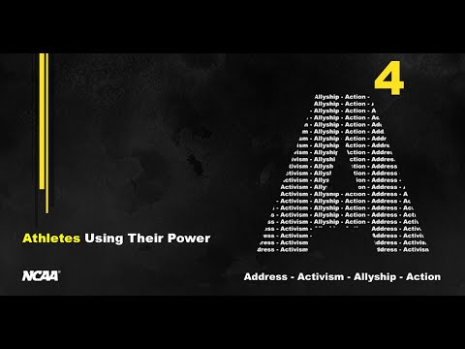

Student-athletes as school representatives of colleges and universities across the United States are a great coalition group that can use their platform effectively for social movements and activist causes. Besides their ideal platform to spread the messages of social movements, student-athletes have also proven themselves to willingly be active participants in their own communities. A recent study “conducted by the Ross Initiative in Sports for Equality surveyed more than 2,000 college student-athletes and found that 79% of respondents felt that student-athletes have an obligation to raise awareness about social justice issues. In addition, 83% of student-athletes surveyed were willing to speak up and do more about issues related to student-athlete activism. Women and athletes of color, individuals who hold less privileged identities in American society, are also more likely to engage in activism than their white male counterparts,” (Mac Intosh, Martin, & Kluch, 2020). As evidence shows, student-athletes are willing and able to use their platform as leaders on their campus for activism.
As student-athletes are already willing to use their leadership platforms effectively, providing them with the resources of SAAC and A4 are great ways to quickly and efficiently get them involved within their own communities, athletic departments, and infrastructures.
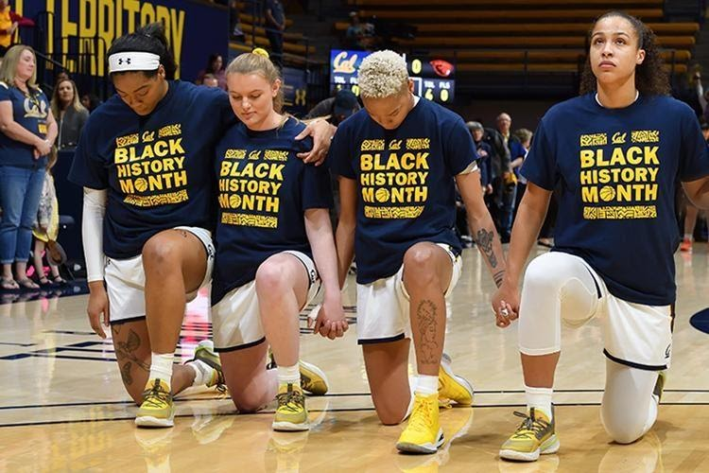

Works Cited
Intosh, Andrew Mac, et al. “To Act or Not to Act? Student-Athlete Perceptions of Social Justice Activism.” Psychology of Sport and Exercise, vol. 51, Elsevier Ltd, 2020, p. 101766, doi:10.1016/j.psychsport.2020.101766.
Kaufman, Peter, and Eli A. Wolff. “Playing and Protesting: Sport as a Vehicle for Social Change.” Journal of Sport and Social Issues, vol. 34, no. 2, May 2010, pp. 154–175, doi:10.1177/0193723509360218.

