INTERNET ACTIVISM & VIRTUE SIGNALING
Suggested further reading:
Twitter and Tear Gas by Zeynep Tufekci
Social Media is Bullshit by B.J. Mendelson
Digitally Enabled Social Change by Jennifer Earl

QUICK LINKS
- Resources
  - Table 1. Platform-specific resources
  - Table 2. University-specific resources
  - Table 3. Other resources

Platform-specific Movement Histories & Functionalities
  - Facebook
  - Twitter
  - Instagram
  - TikTok
- Virtue Signaling
- What now?

Social media has emerged as an important space and tool for activism. You may use the quick links above to selectively read subsections relevant to your movement. The list of free resources intends to help you schedule, organize, and create appealing content on social media. The movement histories subsection goes through a few examples of movement internet activism. The virtue signaling subsection outlines pitfalls to avoid when engaging in internet activism. This section concludes with suggestions on what to do next through a discussion of the risks and benefits of internet activism. To learn more about how to craft your message based on each platform, see the Communications & Messaging section.

RESOURCES
This subsection provides a list of free or student-priced resources you can use to schedule, organize, and create appealing content for your movement.

TABLE 1. PLATFORM-SPECIFIC RESOURCES.
NAME & LINK | DESCRIPTION
Facebook Creator Studio | If you create a Facebook page for your movement, you will have free access to FB Creator Studio. This platform includes analytics (e.g., audience demographics, facebook post performance) and a scheduling mechanism. It’s a one-stop-shop for managing communications and social media posts.
Instagram Creator Studio | Available through Facebook if you link your movement’s Instagram Account to its Facebook page. It has similar functionality to FB Creator Studio.
TweetDeck | Dashboard to help manage Twitter accounts. You can schedule tweets, reply to private messages, follow hashtags, and create tweets all in one place.
TikTok Creator Portal | Site launched by the app’s creators to share information about video creation, content strategy, community guidelines, and paid opportunities. This resource contains articles to learn more about the platform.

TABLE 2. UNIVERSITY-SPECIFIC RESOURCES.
These resources may be available for free or at a discount given your student status.

NAME & LINK | DESCRIPTION
Adobe Products | High-quality video and photo editing software, including Photoshop, InDesign, and Premiere Pro. Students save over 60% ($20/mo), but some universities and colleges offer the software for free.
Figma | Online tool to design figures, phone apps, and other creative elements. Students receive a discount, and some universities and colleges offer this service for free.
Constant Contact | Email marketing tool. You can upload spreadsheets of supporters and prospective supporters to create an internal database and email listservs. Design engaging emails to capture your audience’s attention and organize movement activity. Some universities and colleges offer this service for free.
MailChimp | Email marketing tool with functionality similar to Constant Contact. Some universities and colleges offer this service for free.

TABLE 3. OTHER RESOURCES.
NAME & LINK | DESCRIPTION
Canva | Online graphic design platform, available to all for free. There are certain features that require a paid membership, but you can still create impactful posters, social media advertisements, and other imagery with the free version. Used often to create Instagram infographics.
Pexels | Site to find free stock photos and videos. You can use content here for movement videography and advertisement online.
Unsplash | Same as Pexels, but with alternative options for free stock photos and videos.

PLATFORM-SPECIFIC MOVEMENT HISTORIES & FUNCTIONALITIES
Arab Spring activists notably used Facebook as a platform to amplify the movement and expose political repression. Hashtags such as #BlackLivesMatter, #NOH8, and #MeToo on Twitter—and other platforms—have bolstered awareness of the struggles these movements aim to address. In 2020/2021, activists have taken to Instagram to spread awareness about #BlackLivesMatter and #StopAsianHate via infographics series. And most recently TikTok has provided a platform for decentralized information spreading and on-the-ground media coverage geared toward youth engagement. Although social media is a fairly accessible way to share information, spread awareness, and organize movements, therein lies a tendency toward performative activism and virtue signaling. This subsection details the ways in which movements have used each social media platform as tools in addressing their struggles. You can use this discussion to borrow ideas and heed warnings about how to use social media for your activism. For more information associated with crafting messaging on each platform, see Communications & Messaging.

FACEBOOK: AWARENESS & COLLABORATION
Facebook has enabled activists to connect with audiences broader than ever imagined before its creation in 2004. Scholars, activists, and onlookers alike have pointed to the 2011 Egyptian Arab Spring uprisings as pertinent examples of a “Facebook Revolution.” Activists’ posts on Facebook exposed the brutality of former President Mubarak’s regime, garnering public support and sympathy necessary for success according to certain activists (Engler & Engler 2016, re: Theory to Strategy & Evaluating Success). These posts also encouraged critical public deliberation about the movement in their comment sections (Lewinski & Mohammed 2012). Research has found that Facebook promoted activists’ calls to action, collective organization of protest activity, and provided immediate alternatives to traditional political action that surpassed regime suppression of movement media coverage (Baron 2012).
The Facebook page functionality helps facilitate social movement organization and activity. Facebook pages are public-facing spaces that interested individuals can follow for updates about upcoming events, activities, legislation, or other areas of interest. Pages can also receive and send private messages, as well as track media analytics (e.g., how many people encountered and engaged with their posts). Examples of movement Facebook pages at varying engagement levels include Occupy Wall Street, the Zeitgeist Movement, and Students for a Democratic Society.
Furthermore, Facebook groups are powerful tools for exchanging information and ideas within a movements’ supporter base. You can make groups public or private, depending on whether your movement decides to allow non-group members to see posts within the group. Group admins also have the ability to screen prospective group members through membership requests and brief pre-membership questionnaires. Within the group, supporters can pose questions, share Facebook posts and links from outside the group, create polls, and post pictures/videos. Facebook groups can also act as a space for intra-group collaboration with other movements aimed at similar goals (see Coalition Building for further ideas). Examples of activist Facebook groups include Ann Arbor Alliance for Black Lives, Asians NOW!, and Indigenous Rights Activists.

TWITTER: “HASHTACTIVSM”
Hashtags are an increasingly popular method by which to organize people around a movement. #BlackLivesMatter, #MeToo, and #NOH8 are recent—and quite different—examples of this “hashtactivism.” While hashtags are also used on Instagram, Facebook, and TikTok, they play a significant role in promoting and discovering content on Twitter. Twitter’s Trending page provides links to a series of popular topic-specific hashtags, which users can click on to explore posts (i.e., “tweets”) related to the same topic. Abrego (2008) argues that California Assembly Bill 540 (AB 540) provided undocumented students with a label of “AB 540 students” that made them feel more comfortable expressing their immigrant status and banding together to push for broader rights. Perhaps we can extend this logic to hashtags, which provide labels to boost awareness about an issue.
Scholars have found that viral hashtags can encourage collective consciousness by placing everyday experiences of oppression into the spotlight (Pillay 2020; Tanksley 2019). #BlackLivesMatter, created by Black female activists Alicia Garza, Patrisse Cullors, and Opal Tometi, used social media to deconstruct hegemonic narratives about police and racism in America (Tanksley 2019). The hashtag promoted decentralized story-sharing about Black individuals’ common encounters with police brutality, white supremacy, racism, and injustice. #MeToo, a viral hashtag originated by Black female activist Tarana J. Burke, prompted sharing about survivors’ histories of sexual assault, harassment, and abuse. A main objective of the movement was to spread awareness to show how survivors are not alone (metoo.org). While the objectives, trajectories, and implications of the #BlackLivesMatter and #MeToo movements deserve individual examination, the movements’ similar use of a hashtag to promote consciousness-raising warrants attention.
Actress Emma Roberts poses for the #NOH8 campaign.
Research demonstrates that hashtags may also promote community mobilization and help combat stigmatization around issues (Nobels et al. 2020). Public awareness and de-stigmatization are goals of the #NOH8 campaign, a movement that started in 2008 responding to the passage of CA Proposition 8, a state constitutional amendment that banned same-sex marriage. Supporters of #NOH8 shared photos of themselves with their mouths taped and cheeks painted with the #NOH8 symbol on social media platforms, including Twitter. While this movement started with photographs of everyday Californian supporters, it increasingly involved and publicized images of political leaders and celebrities in support. This shift toward emphasizing elite support is emblematic of internet activism, as mass media coverage that garners large public attention tends to focus on elite actors (Kocks 2016).
This relationship between elite support and mass media calls attention to the role of hashtags in making issues salient to political leaders. Stout et. al (2017) argues that Black politicians are more likely than their white counterparts to use or reshare posts with Black-centered movement hashtags such as #BlackLivesMatter, #MyBrothersKeeper, #BringBackOurGirls, and #SayHerName. But Black female politicians were more likely than Black male politicians to use female-centered hashtags like #BringBackOurGirls and #SayHerName (Stout et. al 2017). If your movement is interested in gaining public support from political leaders, then, you may consider how politicians’ identities relate to your movement goals. You may also wish to consider the size (e.g., amount of hashtag shares) and unity (e.g., repeated hashtags) of your internet activism. Numbers and unity are two components of in-person protest activity that most directly impact politicians’ perceived salience of issues (Wouters & Walgrave 2017). This finding may apply to internet activism, as the hashtag itself is arguably a unifying mechanism for movements to rally around one phrase, and sharing hashtags on social media is a low-barrier way to increase numbers.

INSTAGRAM: INFOGRAPHICS & ART
Instagram is a visual platform in which users must post images alongside text. Infographics are an increasingly popular method of sharing information, organizing activities, and eliciting financial support. These images come in various forms, ranging from text-heavy “carousels” of content to user-made illustrations of injustice.
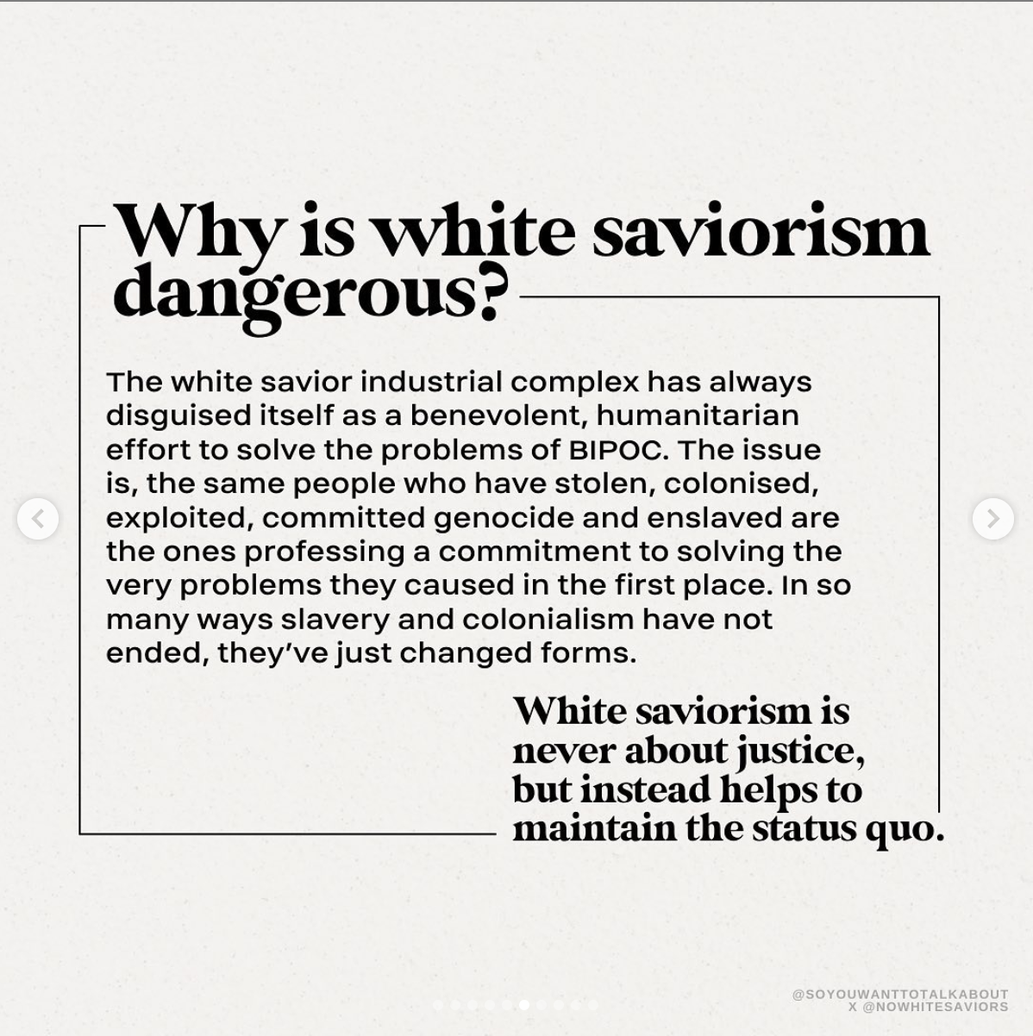
“The White Savior Industrial Complex” via @soyouwanttotalkabout on Instagram

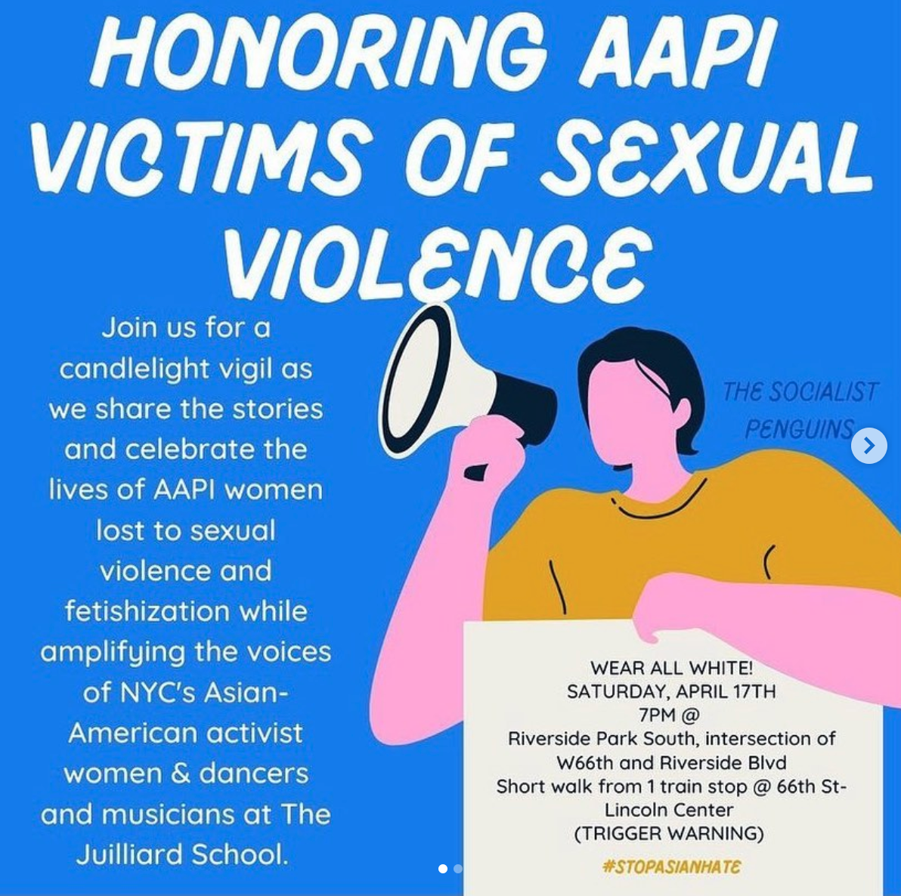
(Left to right) @stop_asianhate | @chnge & @the.daily.don
Infographics are not a new means of communication on Instagram; Cornet et al. (2017) found that infographics accompany on-the-ground protest images, user-created art and photography, commercial images from businesses, and repurposed media (e.g., screenshots and memes) as popular forms of internet activism on the platform.
However, the effectiveness of infographics in raising awareness and furthering movement goals has come under question. On one hand, slideshows of issue-specific information have co-opted business marketing tactics to trick the Instagram algorithm into widely showing activists’ posts on users’ Instagram feeds (Nguyen 2020). Posts with minimalist aesthetics of soft colors and shapes permeate the platform and make their way to Instagram Stories, a mechanism that easily allows users to share others’ posts with their own pools of followers. Movements have used art as a tool for social change throughout history: from symbols like the clenched fist (e.g., Students for a Democratic Society, Otpor) to “We the People” protest posters by Shepherd Fairey. On the other hand, critics point to how Instagram infographics glamorize injustice through “flippant presentations of trauma” that do little to combat the problems at hand (Cho 2021). These posts may simply allow users to signal their agreement with a movement rather than engage in difficult on-the-ground activism to advance the movement’s objectives (re: Virtue Signaling). This debate is ongoing, but acknowledging both sides will help you plan how to engage with Instagram to narrow the gap between your movements’ diagnosis and prognosis (re: Theory to Strategy).

TIKTOK: DECENTRALIZED INFORMATION & STUDENT ENGAGEMENT
TikTok Example A: News Article
TikTok Example B: Duet in Solidarity
TikTok Example C: News Media Clip
TikTok Example D: Hypothetical Conversation
TikTok is a relative newcomer to the social media scene. The platform is designed to quickly make, share, and view 15-second to 1-minute videos. While there are still many unknowns about its algorithms and data-tracking capabilities, TikTok content is demonstrably aimed at teenagers and young adults aged 14 to 24 (Wallaroo 2021). The platform is thus ripe for student engagement, as this age range captures students within typical high school and undergraduate demographics. Unlike other social media platforms, TikTok widely shares user-generated content with non-followers on the For You Page (FYP). This page is an endless stream of videos curated for each user based on their interactions with other content, usually from creators they do not already follow. The FYP’s decentralized nature can help boost your content to audiences outside of your typical supporter base, since users will encounter your videos whether or not they specifically sought them out.
Politicians, pundits, nonprofits, NGOs, activists, and everyday users have taken to TikTok to widely share their political views. From campaign messaging to fact-checks, there is a wide variety of politically-oriented content available on the platform. Students who have engaged with any of these posts are more likely to be shown similar videos on their FYPs. As one New York Times reporter puts it, “in a sense, these TikTok users are building short-form TV networks, each with a cast of talking heads” (Lorenz 2020). Preliminary studies argue that TikTok is increasing youth civic engagement by way of subverting hegemonic forms of media engagement (Burns-Stanning 2021). Like Facebook (Lewinski & Mohammad 2012), its comment section feature may also encourage critical conversations and debate about movement activities and goals. Although further research is necessary to make sense of its political influence, TikTok’s decentralized way of sharing information and focus on youth audiences may prove useful to your movement.

VIRTUE SIGNALING
Virtue signaling is defined as “the act of engaging in public moral discourse in order to enhance or preserve one's moral reputation” (Westra 2021). As a method of self-presentation, social media posts signal one’s interests, beliefs, and activities—all of which are involved in building one’s reputation. In this way, posting about a movement online without taking other supportive actions fits well within the definition of virtue signaling. A closely-related concept is performative allyship, which involves individuals from non-marginalized groups claiming support for marginalized groups in “unhelpful ways” (Kalina 2020). Using social media only for the sake of showing solidarity is likely “unhelpful” to the extent that actionable items and change do not necessarily follow.
Before engaging in internet activism, then, it is important to consider how your posts might (1) be received by different audiences and (2) impact the struggles your movement aims to address. If your post might cause audiences to be impressed without impacting the struggles your movement aims to address, it is possible you are virtue signaling. Posing with a group of friends at a protest, for example, may showcase your support for a movement. But if you do not continue to put in the work after that singular protest, the photo you posted falls short of impact by only signaling your virtues. This example only intends to provide a framework for understanding virtue signaling and is not exhaustive. Your answers to the above questions—a true assessment of the reasoning behind and impact of your social media activism—are more indicative of your actions.

WHAT NOW?
Social media is a beneficial tool for your activism if you are cognizant of the medium’s tendency toward virtue signaling and other pitfalls. Commentators and researchers alike label internet activism as “slacktivism” due to the low-costs of social media as a platform for signaling support. But some scholars refute these claims by showing how publicly sharing about a movement is positively correlated with offline volunteerism and action related to the cause (Lane & Cin 2018; Lee & Hsieh 2013). The literature is inconclusive with regard to establishing whether the benefits outweigh the detriments of using social media for activism. Nevertheless, social media has provided unique ways to raise collective consciousness, circumvent hegemonic forms of information-sharing, and engage youth—which we would be remiss to ignore.
The historical examples of internet activism outlined in this section may serve useful in assessing how you want to engage with social media. Facebook comment sections, pages, and groups are exceptional spaces for intra-/ inter-movement collaboration and discourse. Hashtags on Twitter (and other platforms) provide a foundation for building collective identities around struggles. Instagram infographics and photos help individuals digest the complexity of struggles your movement aims to address. TikTok’s For You Page and predominantly student-aged audience may facilitate information-sharing across diverse audiences and inspire greater youth engagement.
However, these functionalities only scratch the surface of what social media is capable of doing. We encourage you to explore the platforms included in this section, as well as others (e.g., LinkedIn, Snapchat, WeChat), to determine how to best use them for your activism. Keep in mind the risks of virtue signaling, and be sure to use social media as a supplemental—rather than sole—tactic to advance your movement.

