CRAFTING YOUR MOVEMENT’S MESSAGE

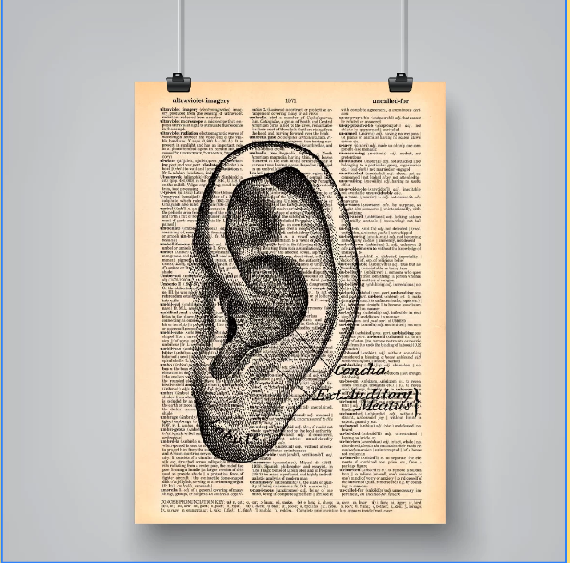
In his book, Words That Work, the renowned political and communications consultant, pollster and pundit Frank Luntz presents a playbook for any successful campaign or political movement. Here’s how to build an effective, powerful message for your student movement using Luntz’s framework:

Rule #1
Simplicity: Use Small Words

“Avoid words that might force someone to reach for the dictionary… because most people won’t. They’ll just placidly let your real meaning sail over their heads or, even worse, misunderstand you. You can argue all you want..., but unless you speak the language of your intended audience, you won’t be heard by the people you want to reach... Simplicity counts.” (Luntz 4-5)

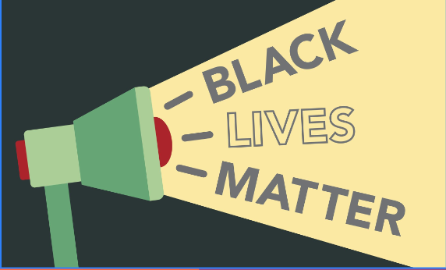
A large mistake of some movements is the assumption that people already know what you’re talking about, or even care for that matter. You have to break it down so that the average person who might not be aware will understand you. Nobody, especially not a student, wants to hear large amounts of academic jargon outside of the classroom.

Rule #2
Brevity: Use Short Sentences

“Be as brief as possible. Never use a sentence when a phrase will do, and never use four words when three can say just as much… The most memorable political language is rarely longer than a sentence. Sometimes two or three words are worth more than a thousand.” (Luntz 7-8)

Think about the slogans you’ve heard for recent social movements. Black Lives Matter. Say Her Name. I Can’t Breathe. Defund the Police. They’re all simple, to the point, yet extremely impactful. You don’t have to say a lot to say a lot. Make sure that you’re being precise and as effective as possible with the fewest words possible. Students have a lot going on, so you need to be able to catch their attention and keep it which brevity will help you to do.
Rule #3
Credibility Is As Important As Philosophy

“People have to believe it to buy it. As Lincoln once said, you can’t fool all of the people all of the time. If your words lack sincerity, if they contradict accepted facts, circumstances, or perceptions, they will lack impact… The words you use become you — and you become the words you use.” (Luntz 8)

Before you can convince anyone else, you have to believe in your message. The best way to do this is making sure that you have done extensive research on the issue or topic that your movement focuses on. You want to get in front of people and be confident that you actually know what you’re talking about.
Rule #4
Consistency Matters

“Too many (activists) insist on new talking points on a daily basis, and companies are running too many different ad executions. By the time we begin to recognize and remember a particular message, it has already been changed.” (Luntz 11)

Be consistent with your movement’s message. If you say it enough, eventually it will stick. It also helps to have a designated speaker, or a couple of main speakers. These people will be responsible for speaking and communicating your movement’s goals and demands at events. It might be weird to navigate power dynamics and organizational structure, but you don’t want “too many hands in the pot”, or in this case: too many voices on the megaphone.
Rule #5
Novelty: Offer Something New

“In plain English, words that work often involve a new definition of an old idea… What matters most is that the message brings a sense of discovery, a sort of “Wow, I never thought about it that way” reaction.” (Luntz 13-15)

If there is already a movement like your that exists, what are you offering that’s new? There are so many movements and so many issues that are out there. You have to think about how you’ll stand out. Be innovative or bring something new to the table.

Rule #6
Sound and Texture Matter

“The sounds and texture of the language should be just as memorable as the words themselves. A string of words that have the same first letter, the same sound, or the same syllabic cadence is more memorable than a random collection of sounds.” (Luntz 16)
Rule #7
Speak Aspirationally

“Messages need to say what people want to hear… The key to successful aspirational language is to personalize and humanize the message to trigger an emotional remembrance.” (Luntz 18)

While the driving force or issue behind your movement might be really serious, or depressing even, your message has to be aspirational so as to inspire the people who are listening. You cannot bring about change by being defeated or dwelling. You have to be forward thinking, hopeful, and pioneering, which should be reflected in your message.

Rule #8
Visualize

“Paint a vivid picture… the slogans we remember for a lifetime almost always have a strong visual component, something we can see and almost feel.” (Luntz 20)
Rule #9
Ask a Question

“A statement, when put in the form of a rhetorical question, can have much greater impact than a plain assertion. If unemployment and inflation are up and confidence in the future is down, telling (citizens) that life has gotten worse, while clearly factual, is less effective than asking (citizens) "Are you better off today than you were four years ago?" (Luntz 23)

Asking a question is the best way to leave people thinking. And when you’ve left them thinking, you're on the right track. The goal of your message should always be getting people to think critically about what they might not have been paying attention to before.

Rule #10
Provide Context and Explain Relevance

“You have to give people the “why” of a message before you tell them the “therefore” and the “so that.”… if it doesn’t matter to the intended audience, it won’t be heard. With so many messages and so many communication vehicles competing for our attention, the target audience must see individual, personal meaning and value in your words.” (Luntz 26-27)

You have to get people to care about your message. Ok, your message and your movement is cool. But how does it relate to me? That is the question you have to think about from your intended audience. Your message should be specific, but general enough that the masses can relate with it.

USING SOCIAL MEDIA TO ORGANIZE PEOPLE AND SPREAD YOUR MESSAGE

Students are generally well-placed to use social media in their organizing efforts. Most other students are young and very familiar with navigating these platforms. This makes them an excellent place to access and organize people—and to quickly spread information. These functions are only more important in post-covid organizing, where it is more difficult to gather people in person for meetings, information sessions, and events.

Organizers should keep in mind that social media is a powerful tool for reaching people who otherwise would not be involved in your cause (Maher and Earl 2019). Social media work should focus on reaching the widest audience possible and building an inclusive and welcoming brand. Here are a few tips for using different social media platforms in your activism:

Twitter
  - Twitter is an excellent platform for public messaging and promotion. The retweet function means that posts are shared more widely and can be easily spread through new networks. This can give your organization a chance for exposure to new people and organizations that can be recruited to your cause. When your movement organization or one of its members tweets something noteworthy, catchy, inspiring, or important, retweet the message and have your peers do the same—the more eyes that see your messages, the better.
  - Twitter’s 280-character limit means that clarity and short messages are key. Successful posts will use short, punchy sentences with memorable, comprehensive slogans (see messaging tips in previous section).
  - Hashtags can also help spread your tweets to new audiences. Search for hashtags that are commonly used by other people or organizations doing work with your cause—and boost their work if you or they can benefit from it. If there are no commonly used tags, try developing a usable hashtag with your peers.
Instagram
  - Instagram’s visual medium and sharing tools make it one of the best places to present and spread information about your cause. It is also widely used by young people and is thus one of the best ways to reach new people.
  - Infographics, lists, and charts can be eye-catching and informative if they are well-made (see social media messaging strategies section for tips and ideas).
  - These posts are also easy to share. Users can place an existing post on their story, sharing it with their followers. In terms of spreading your message, this feature essentially works like Twitter’s retweet function; repost quality content and have your peers do the same with whatever your organization may post.
Facebook
  - Young people use Facebook at lower rates than other social media, but it can still have a place in active organizing.
  - Many students regularly use Facebook to plan and boost events. If you are planning some kind of public action, it could help to create a Facebook event for it and have all of your associates RSVP and share the event with their friends. Many organizations find new members this way.
  - Better yet, create a Facebook page for your movement organization. This offers a new space to market your ideas and expose your organization to more people (see social media messaging strategies section). A well-curated page could draw in plenty of new members.
Slack
  - Slack is a messaging app that has some versatile features that can be valuable for organizing large teams of people.
  - Slack is particularly useful because it allows users to create sub-groups within a group message where the sub-group can talk in its own message stream. For example, if your group is organizing a public event, the broader group could be divided into teams managing outreach, event planning, communications and media, and safety, each with their own space in Slack to plan and discuss their work. At the same time, the larger group chat is still easily accessible and linked. This offers some opportunities for simplifying intergroup communication.
Snapchat, WhatsApp, GroupMe and Other Messaging Apps
  - These are free messaging apps available to anyone. These platforms are primarily useful because lots of students already use them—especially Snapchat. They are perfect for quickly creating a space to communicate with new people.

Activists should keep in mind that connections through social media can be easy, but also that they can disappear easily (Maher and Earl 2019). An important element of all social media messaging should be building long-term relationships with supporters and offering concrete ways to stay involved with the cause and connected in your network. Encourage interested supporters to follow your accounts and share your posts and consider sharing links to related accounts and content.

Citations
Maher, Thomas V., and Jennifer Earl. “Barrier or Booster? Digital Media, Social Networks, and Youth Micromobilization.” Sociological Perspectives 62, no. 6 (December 2019): 865–83. https://doi.org/10.1177/0731121419867697.

Luntz, Frank I. Words That Work: It's Not What You Say, It's What People Hear. New York: Hyperion, 2007. Print.

