Erin Daly
PHYSICAL SPACES FOR ACTIVISM:

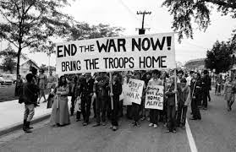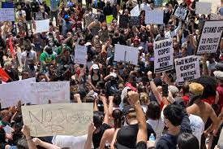

Importance of Physical Space

Opening space for new relations is of the utmost importance to allow new relations to be put in practice. As Gelderloos argues extensively in his work “The Failure of Nonviolence,” seizing space is a major component and criteria in defining and measuring a social movements success. Seizing space allows for a movement to ensure that there is room for new relations and practices to be put into place. Physical space is crucial for communities to share direct access to means of survival, room for individuals to organize, be active, and have room to grow in their surroundings, as well as give individuals the opportunity to make their own decisions and have freedom of choice within that space. Further, it ensures the safety and protection of individuals from outside authority. Although this space, specifically in a capitalist state, will be reconquered by the State, it allows for self-organization and growth within movements.

- Proximity has been found to be highly positively correlated with the likelihood of mobilization. (Tilly, 2003)
- Campus space facilitates mobilization by facilitating tight networks and endogenous solidarities (Zhao, 1998)
- Dormitory spaces in China helped mobilized migrant workers to participate in collective protests. (Chan and Pun, 2009)
- Research about the relationship between space and social movements has increased significantly since the 2017 rise in Occupy movements with the following being researched / concluded:
  - How protestors behave and spatially interact with police
  - Contention over space is regarded as an important way to challenge state power.
  - Social media increasingly used to facilitate social movements and generating new experiences of public space
  - Importance of face-to-face interactions as motivating forces.

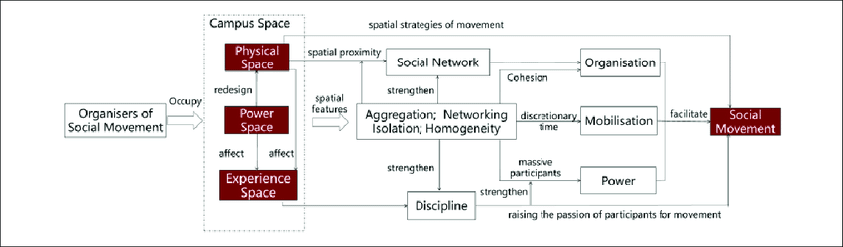

Obtaining Physical Space

For organizations such as Occupy, obtaining physical space is crucial for the success of the movement as its premise demanded that activists hold public space. Occupation of space became decisive for both participants and outside observers. As long as protest encampments remained intact in places such as parks, government centers, or in state buildings, the movement was succeeding in its stated goal. In the instances of Occupy, once police evicted camps the movement had essentially been defeated. Occupy is just one example of where obtaining physical space is crucial for a movement to reach its goal. When individuals hold space, not only are they physically offering room for growth, understanding and change, but also providing a safe space for people to come together and fight alongside each other, and promote a better tomorrow. As activists, we focus on the relation between democracy, social change and public space and focus on how to keep a hold on public spaces, how to make new ones, how to engage people in the struggle for public spaces and how to use public space as a site for social change.

Obtaining physical spaces has many layers and levels of complexity, but at the most basic level, we must start by finding shared spaces for training which are physically and socially accessible to as many people as possible. This can be accomplished by finding a convenient location where all individuals have access and are able to attend as well as large enough to comfortably fit all individuals. If this event is to be held on a campus, ensure students from all over campus have access to meetings and events as well as be conducive to most student schedules. Starting small and ensuring that the organization can meet privately, and safely offers activists to opportunity to plan and develop, to push the process of obtaining space further to large community gatherings.

Marches, Protests, and Rallies

When it comes to seizing physical space, the terms “march”, “protest” and “riot” are often thrown out almost interchangeably in the media. While movements often blend the lines between these three things, they are all effective in obtaining physical space and drawing attention to a movement. Benefits include:
- Applying pressure to elected officials / targets to demonstrate support for the issue
- Generate publicity and educate the public about the cause
- Energize activists

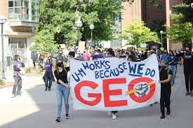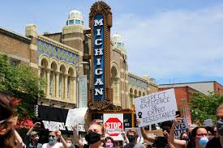

Planning a Rally / March
- Do research regarding other events happening locally as well as whether nearby communities will be holding a similar relevant event.
  - Check Facebook pages and other social medias accounts of organizations and reach out about both time conflicts and support
- Pick symbolically significant locations and times/ dates if possible to draw the most media coverage.
- Rallys / protests may require permits depending on size – plan ahead and know your rights.
  - Ann Arbor Permits can be obtained using the following links:
    - https://www.a2gov.org/departments/communications/film/Pages/Permits.aspx
- Recruit !
  - Be sure to spread the word and post on social media to gain following and ensure a successful / impactful protest
  - Reach out to groups with similar causes
- Invite the Press
  - Invite local media and provide specific dates and times and reasons for the protest
- Be Loud and Visible and Understand your First Amendment rights
  - Comply with local laws but understand your rights to be there and protest.

Safety:

Preparation for providing first aid at protests.
- Riot Medicine (the practice of medicine in an “adversarial environment” )
  - A group of medics who will be available at protests and marches to provide aid such that protesters may engage safely and with protection.
    - Roles: Hydration / handing out water, caring for injured protesters and bystanders, providing interventions for combatants in more physical/ dangerous environment
    - consult local laws to understand when you can be relieved of duty by other medical professionals such as Emergency Medical Services (EMS) personnel arriving on the scene

- Police blockades that do not allow ambulances through, and EMS movements may be disrupted by comrades’ actions.

- St. Paul Principles
  - Principle 1: Respect diversity of tactics
    - Not all individuals / medics are comfortable with violent confrontations, and therefore they are entitled to determining their own level of safety.
    - Some protest groups may not want clearly marked medics because it draws unwanted attention from law enforcement.
  - Principle 2: separation of time and space
    - used to isolate legal risk, risk of repression, and risk of violence faced by participants and other medics.
    - Walking around in a full EMS uniform with protesters who are trying to blend in may draw attention they do not want.
    - Protesters need to be aware of medical support and not drag them into confrontations they are not prepared to handle.
  - Principle 3: Avoid Internal Conflict:
    - Avoid criticizing individuals and groups, medical or otherwise, in a public way that can be used by police or media to show a divided movement

  - Principle 4: confidentiality
    - medics never provide information about comrades, organizations, or actions to the police or the State.

The St. Paul Principles came out of the political resistance to the Republican National Convention (RNC) in St. Paul, Minnesota in 2008. The principles were agreed upon by the various groups that were organizing together in order to maximize their collective impact. These principles have endured in anarchist and non-anarchist circles in part because they effectively counter State disruption of organizing.

